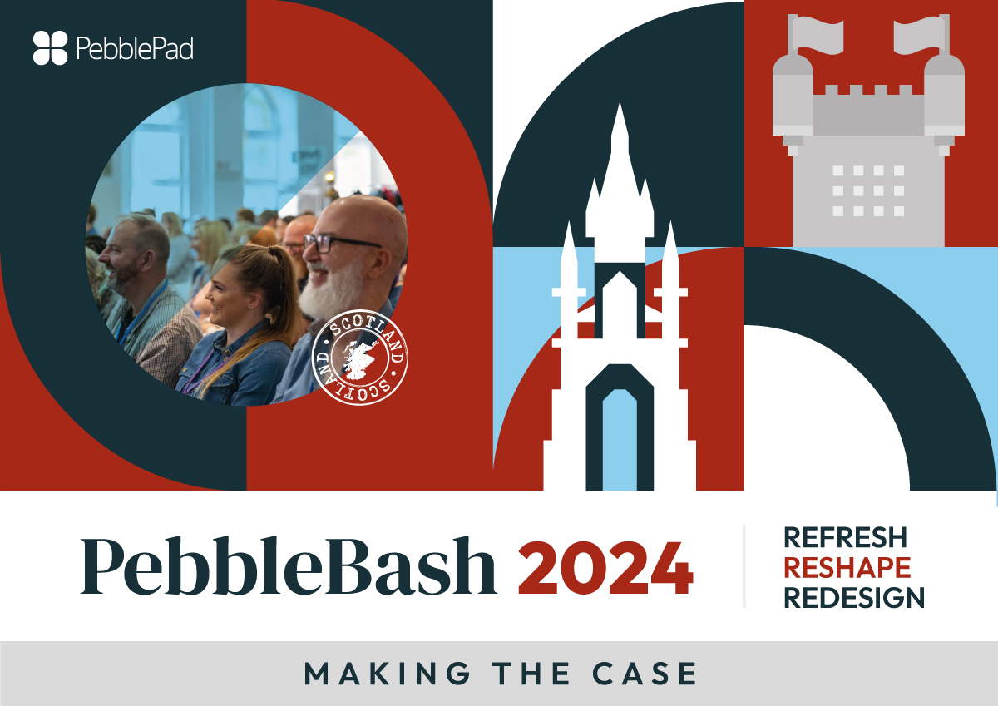

Dear/Hi [Name]

I would like to attend PebbleBash 2024, a biennial international PebblePad conference, to be held in Edinburgh, Scotland, in June 2024. PebbleBash brings together PebblePad practitioners from around the globe to share practice and discuss the opportunities and challenges that the use of a learning and teaching platform like PebblePad presents.
As many of PebblePad’s customers are undertaking initiatives to reshape the curriculum, PebbleBash provides an opportunity to exchange insights, best practice and renew ideas for creating exceptional learning experiences, aligned with evolving student needs.
I think there are four compelling reasons why attendance at PebbleBash 2024 is a great idea – I’ve briefly outlined these below…

Reason 1: I’ll have the opportunity to learn more about tried and tested methods from expert practitioners
PebbleBash is an event led by the PebblePad community. I’ll be able to learn how other universities have tackled and overcome the challenges we are facing at [INSERT UNIVERSITY NAME].
Reason 2: The depth and breadth of practice on show
- I’ll be able to learn about how PebblePad is being used to helpeducation institutions tackle some of the key themes in the HE sector:Authentic assessment and feedback
- Flexible learning design
- Belonging, wellbeing and success
- Employable and future-ready
- Professional identity and capability
As well as learning about areas of practice beyond my discipline/subject area, including:
- Strategies for implementing PebblePad at scale
- Scaling up use across a school, faculty, or organisation
- Resources and processes for training and support
- Using PebblePad to support:
  - personal tutoring
  - research
  - learning and teaching
  - mentoring
  - professional development
  - work integrated learning
  - authentic assessment
  - flipped classroom approaches
- Reporting and learning analytics
- Integrations and administration

Reason 3: Sharing our voice and opinions
Not only will I be able to network with the PebblePad community, I will have the opportunity to meet and speak with the PebblePad leadership, implementation and development teams. I will hear about, and have a chance to provide feedback on, the PebblePad roadmap and longer-term direction.

Best of all I will get to share some of the great practice we are engaged in, putting our own examples on the map and bolstering the reputation of our university as forward-thinking and trailblazing educators.
Reason 4: Value for money
PebblePad is subsidising costs so that registration is being kept as low as possible. Despite years of high inflation, ticket prices are only 8% higher than those in 2020.
Thank you for considering my request.
Yours sincerely,
[Name]

Some quotes from our last PebbleBash event:
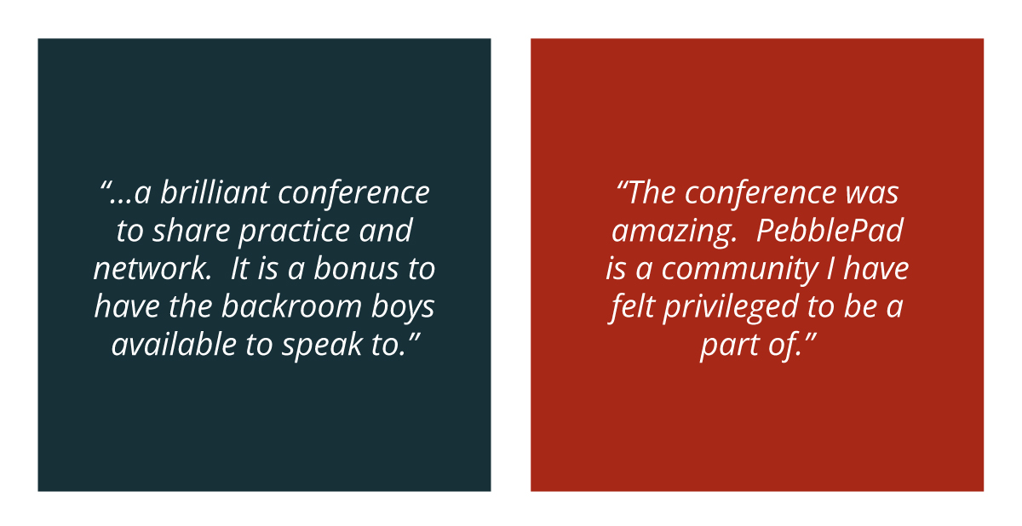
“Fabulous exchange of best practice. Have learned an awful lot and look forward to how busy our team is going to be in the coming months!”

A sample of videos from our one-day MiniBash events:
MiniBash UK 2023
MiniBash Melbourne 2022
MiniBash Brisbane 2022
MiniBash Perth 2022
MiniBash UK 2022

